Openshift Build,Deployments and Image streams

Builds:

1.Webhook trigger : build the app image whenever the code changes

2.Image trigger: build the app image whatever the base image or app runtime changes

3.Build hooks: test the app image before pushing it to an image registry

Deployments:

Deployment trigger: redeploy app containers whenever configuration changes or the image changes in the openshift registry or upstream registeries

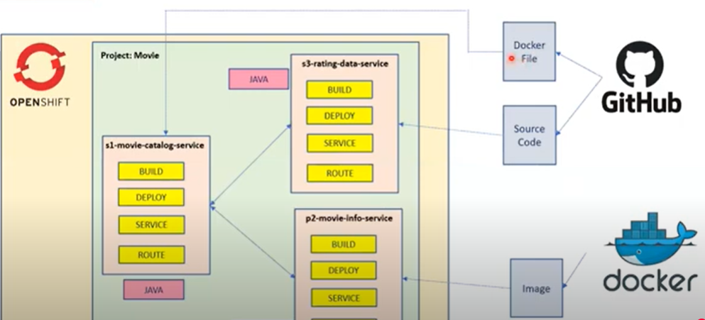

Process of openshift

1.Build

2.Deploy

3.Service

4.Route

From Github to openshift:

1.Build and Deploy the application from github to Openshift cluster

2.Using SourceToImage(S2I)

3.Create service and Route